**Practical 2:**

**Aim:**

**Write an assembly program to perform Addition, Subtraction of:**

1. **two 8-bit numbers**
2. **two 16-bit numbers**
3. **two 32-bit numbers**
4. **two 64-bit numbers**

**Note: get the data form memory locations, result should be available at memory location**

**Description:-**

**MOV:** Transfer data from one register or memory location to another register or memory location.

**ADD:** Adds immediate data or memory location or register to memory location or register. Source and destination for ADD can’t be memory location.

**SUB:** Subtracts immediate data or memory location or register to memory location or register. Source and destination for SUB can’t be memory location.

**ADC:** Perform addition operation with Source operand and Destination operand and Carry Flag (CF).

**SBB:** Subtract Source operand and borrow flag (CF-reflect result of previous calculation) from destination operand and result is saved in destination operand.

**1 : Two 8-bit Addition & Subtraction**

**Code :-**

MOV AX, 2000H

MOV DS, AX

MOV [0001H],12H

MOV [0002H],10H

MOV AL, [0001H]

ADD AL, [0002H]

MOV [0003H], AL

SUB AL,[0002H]

MOV [0004H],AL

HLT

**Output :-**

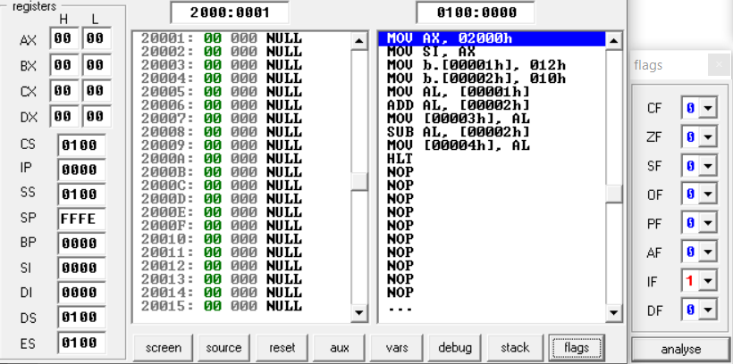

**2 : Two 16-bit Addition & Subtraction**

**Code :-**

MOV AX, 2000H

MOV DS, AX

MOV [0001H], 2001H

MOV [0002H], 2002H

MOV AX, [0001H]

ADD AX, [0002H]

MOV [0003H], AX

SUB AX, [0002H]

MOV [0004H], AX

HLT

**Output :-**

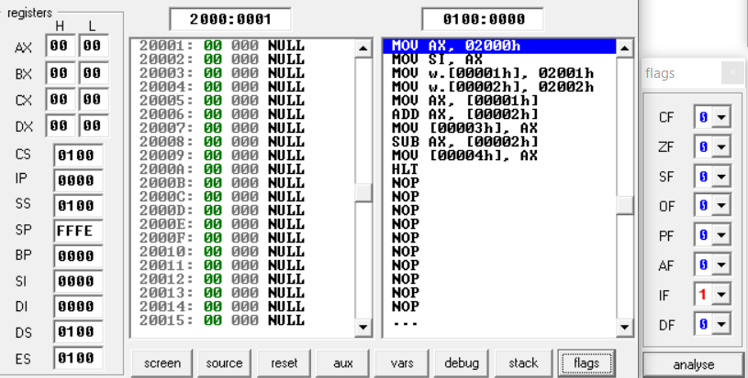

**3 : Two 32-bit Addition & Subtraction**

**Code :-**

MOV AX, 3000H

MOV DS, AX

MOV [0001H], 1002H

MOV [0003H], 12H

MOV [0004H], 1003H

MOV [0006H], 20H

MOV AX, [0001H]

ADD AX, [0004H]

MOV [0007H], AX

MOV AL, [0003H]

ADC AL, [0006H]

MOV [0009H], AL

MOV AX, [0007H]

SUB AX, [0004H]

MOV [000AH], AX

MOV AL, [0009H]

**Output :-**

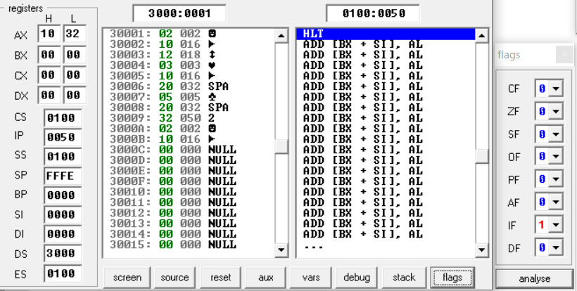

**4 : Two 64-bit Addition & Subtraction**

**Code :-**

MOV AX, 3000H

MOV DS, AX

MOV [0001H], 1002H

MOV [0003H], 1003H

MOV [0005H], 1004H

MOV [0007H], 1005H

MOV AX, [0001H]

ADD AX, [0005H]

MOV [0009H], AX

MOV AX, [0003H]

ADC AX, [0007H]

MOV [000BH], AX

MOV AX, [0009H]

SUB AX, [0005H]

MOV [000DH], AX

MOV AX, [000BH]

SBB AX, [0007H]

MOV [000FH], AX

HLT

**Output :-**

